KAARTHIKA PRIYADHARSHINI M

Assignment:-(Module-3 Python)

3. s1="kpd"

s2="priya"

print("String-1: ",s1)

print("String-2: ",s2)

print("Concatenate: ",s1+s2)

print("String reverse: ",s1[::-1])

print("String Slice: ",s2[2:4])

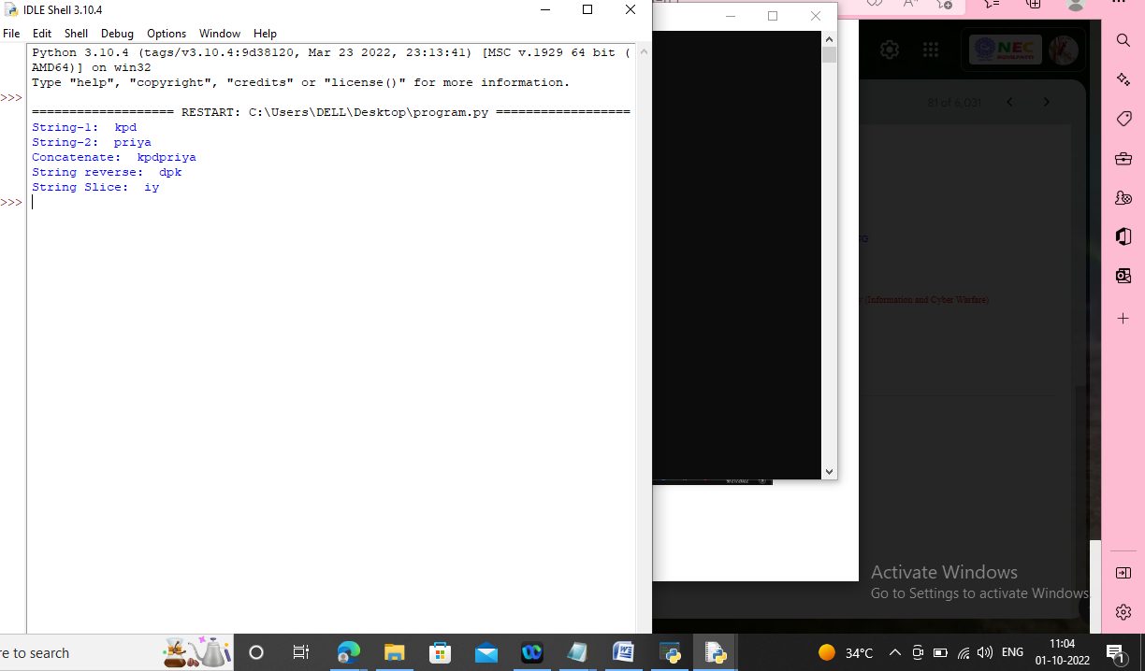

.2. while(True):

print("\nCalculator:\n1.Add\n2.Subtract\n3.Multiplication\n4.Division\n5.Exit")

print("Enter the choice:")

n=int(input())

if(n==5):

break

n1=int(input("Enter the First number:"))

n2=int(input("Enter the second number:"))

if(n==1):

print("Answer:",n1+n2)

elif(n==2):

print("Answer:",n1-n2)

elif(n==3):

print("Answer:",n1\*n2)

elif(n==4):

print("Answer:",n1/n2)

else:

break

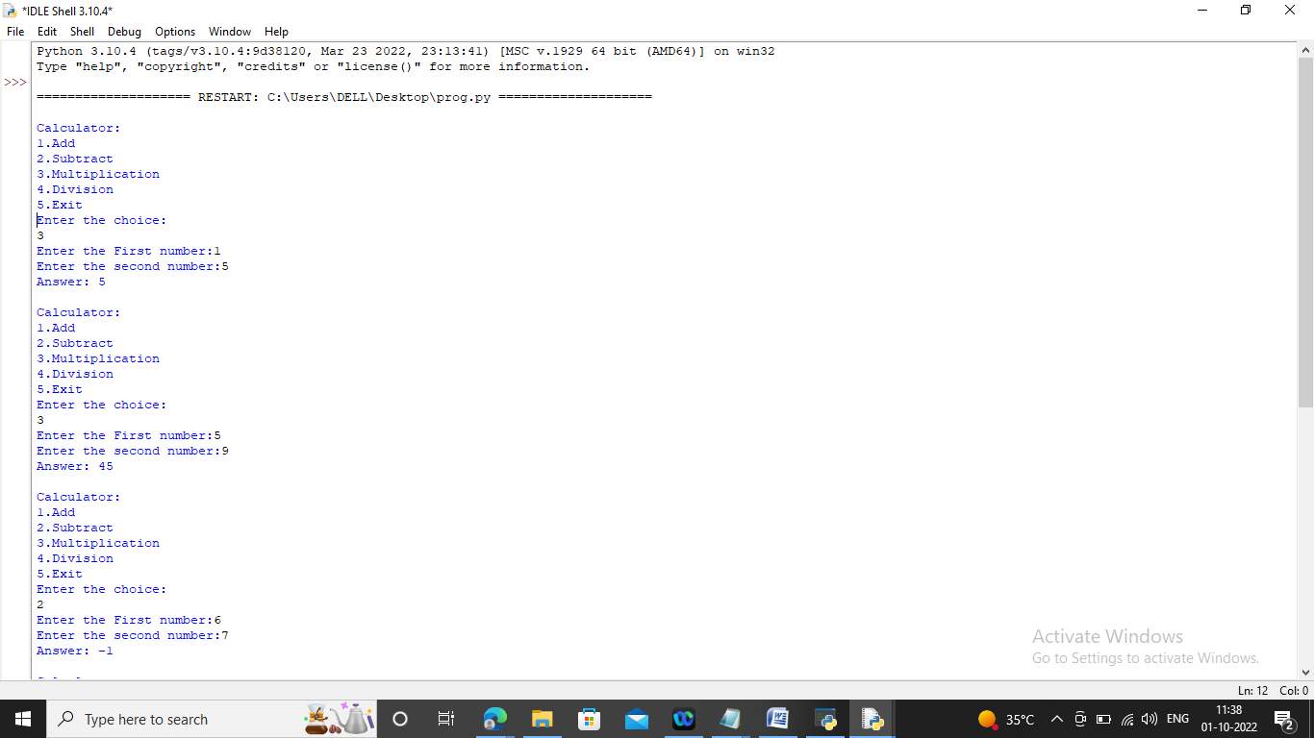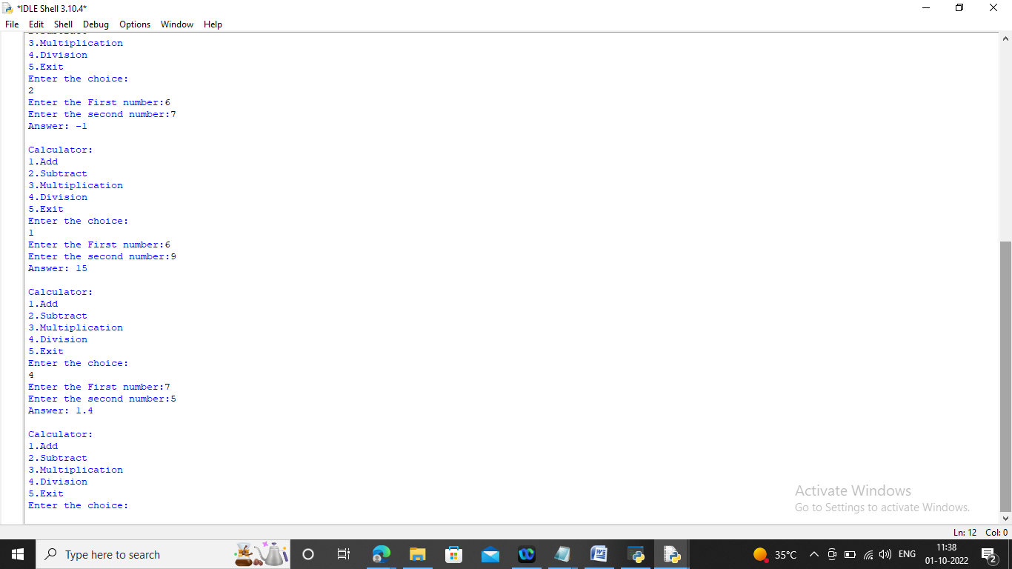

1. n=int(input())

list=[]

for i in range(0,n):

c=input().split()

if c[0]=="insert":

list.insert(int(c[1]),int(c[2]))

elif c[0]=="print":

print(list)

elif c[0]=="remove":

list.remove(int(c[1]))

elif c[0]=="append":

list.append(int(c[1]))

elif c[0]=="sort":

list.sort()

elif c[0]=="pop":

list.pop()

else:

list.reverse()

